**Donkey Car Training Guide**

**Collect Data**

1. Practice driving around the track a couple times.
2. When you're confident you can drive 10 laps without mistake, restart the python manage.py process to create a new tub session. The joystick will auto record with any non-zero throttle, so you should be able to start a new tub by stopping the car and starting it back up again – just make sure you don’t stop while you’re driving or it may start a new session from the point at which you stopped.
3. If you crash or run off the track, stop the car immediately and set it back on the track.
4. You will have to start a new session every time you crash, so try not to mess up!
5. After you've collected 10-20 laps of good data (5-20k images) you can stop your car with Ctrl-c in the SSH session for your car.
6. The data you've collected is in the ‘data’ folder in the most recent tub folder.

**Transfer Data**

Since the Raspberry Pi is not very powerful, we need to transfer the data to a PC computer to train. Transferring data can be done by using a flash drive or rsync. We will use a flash drive since it typically has less bugs.

1. First, plug the monitor, keyboard, and mouse into the pi. If it is not already powered up, do so now.
2. Once you are in the Raspberry Pi OS, go to the File Manager and you can find the most recent data tubs my going to home>pi>mycar>data.
3. Plug in a flash drive, and copy the desired tub(s) to the flash drive.
4. Eject the flash drive and plug it into the host PC, and copy the tub(s) to the host PC’s data folder.

**Clean Data**

1. Open an anaconda terminal type and change your working directory to your donkey car data/tub folder. typing in cd data_directory
2. Enable the donkey environment by typing in conda activate donkey
3. typing in tubclean “name of tub” example tubclean 2020060223-Shackspace/
4. open an internet browser and type in localhost:8886 where we can select a tub
5. Once tub is selected you can play the video by pressing the play button. If you press it again you can pause. To rewind just press b and to split you press c.
6. Once you split data you can give it a check mark to mark it to be removed
7. Once the whole tub has been cleaned select the red save and delete checked training Data button. This will save a cleaned version of the tub which will improve training performance.

**Train Data**

1. On the host PC, type ‘anaconda’ into the search bar and open the anaconda terminal.
   1. If nothing comes up, Anaconda may still have to be downloaded onto the PC.
2. In the anaconda terminal, type conda activate donkey followed by python ~/mycar/manage.py train -–tub<your tub> --model ./mycar/models/Pilot1.h5
   1. If you get the “usage” error, you may have to specify no tub by using python ~/mycar/manage.py train -–model ./mycar/models/pilot.h5 –just make sure that your tub is the only one in the folder, or else it will train all the tubs.
3. It will train (may take 10-30 minutes) and output a ‘model’ file of the data. Copy the model file back to flash drive and to the pi’s ‘models’ folder.
4. You can always change the name of your outputted model by changing “Pilot1” to your choice of model name for your specific application.

**Train Data with other neural network types**

1. In the anaconda terminal, type conda activate donkey
2. Initialize training with the --type=<model_type> tag into the anaconda working directory python ~/mycar/manage.py train -–model ./mycar/models/pilot.h5 --type=linear
3. Should see the message “get_model_by_type” model Type is: <model_type>

**Types of Neural networks (More details at** [**https://docs.donkeycar.com/parts/keras/**](https://docs.donkeycar.com/parts/keras/)**)**

* linear
  + Default - Usually works well but may fail to learn throttle well
* Categorical
  + Breaks up stearing and throttle decisions – very robust
* Latent
  + Learns an additional latent vector which can improve steering control
* rnn
  + Tough on PI3
* 3d
  + Tough on PI3
* Behavior
  + Takes more effort to train

**Setting Autopilot speed**

1. To limit the max velocity for ai pilot set in myconfig.py the variable AI_THROTTLE_MULT to a value of your liking

AI_THROTTLE_MULT = 1.0 # this multiplier will scale every throttle value for all output from NN models

**Drive Car**

1. In the SSH session or directly from the pi terminal, type python ~/mycar/manage.py drive –-model ~/mycar/models/Pilot1.h5
2. Open your web browser, and make sure ‘Local pilot’ is selected; once you do so, it should start driving itself.
   1. Make sure whatever battery you train with, you use during autonomous mode.
   2. 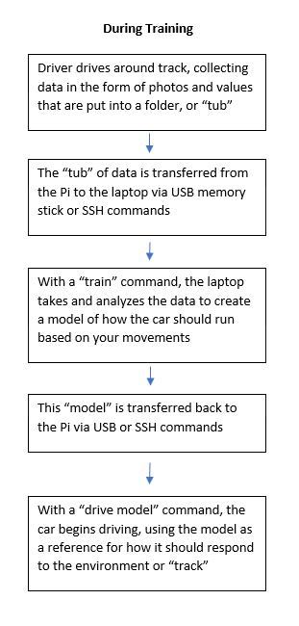When you want to stop driving, make sure to exit the browser, use Ctrl+C in the PuTTY terminal to stop the script, and exit the PuTTY window before you power down the pi.

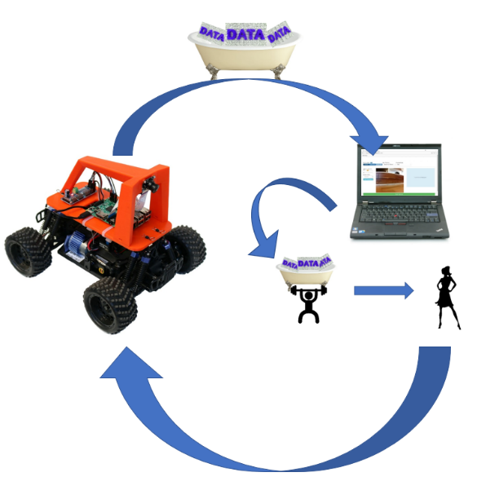

Visual and graphical representations of training